Solutions
- Highlight the name, David Mayer, and change it to the “Title” style. Then make sure the name is centered in the same place it was before.
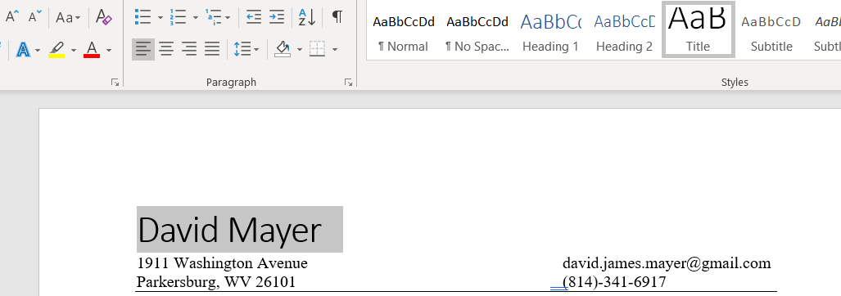
As the text is highlighted, click “Title”.
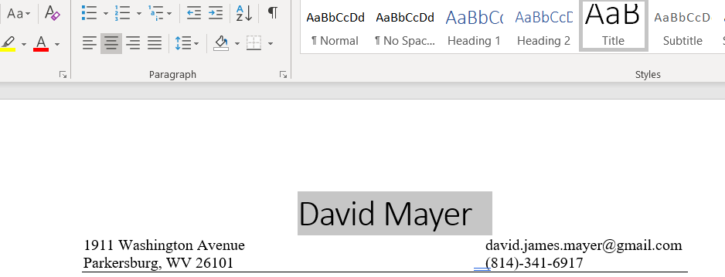
Then click “Center”.
- Change the address from “1911 Washington Avenue to “117 Top of the Rock Drive
Parkersburg, WV 26101” Morgantown, WV 26508”
Note: you should keep the email address and the phone number in about the same place they were before.
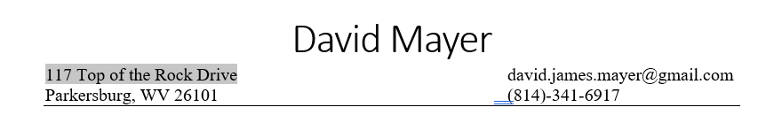
I just typed in the new information. No new formatting was necessary.
- Change all the headings (Education, Experience, Accomplishments, Skills, and Hobbies and Interests) to “Heading 1” style. You may need to underline the headings again.
When I highlight “Education” and change it to Heading 1, the underline disappears, so I need to underline it again.
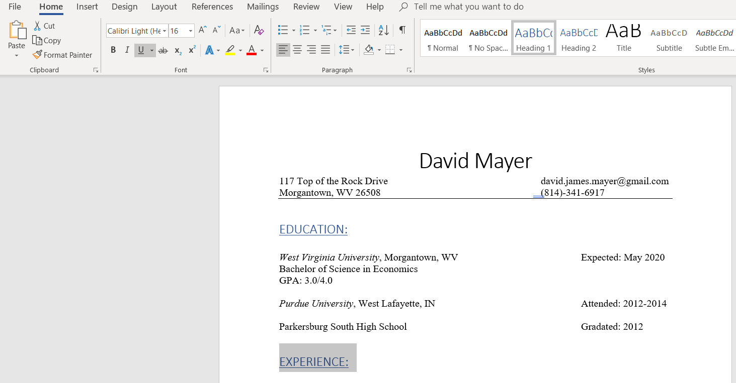
1
2
After clicking Heading 1 (#1), I go over and click “Underline” (#2). Do the same for all the headings.
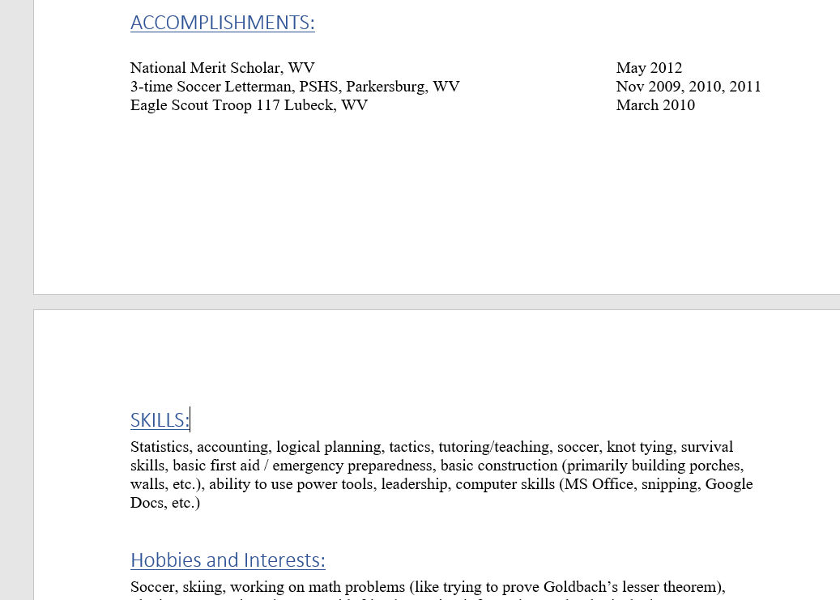
- Add new work experience right under the Experience heading. The information is:
Circles MOV, Parkersburg, WV, July 2019 – August 2019
Finance Intern
Assisted with meetings and gave presentations
Edited website and updated documents
Made spreadsheets and PowerPoint presentations

Note: Use “Italics” under “Font” for Circles MOV. Make bullet points for the list under Finance Intern. Try to keep the format the same as the rest of the work experience.
This might be the toughest instruction. I started by adding a line right above “WVU”.
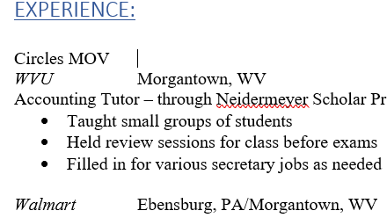
I lined up the start of “Morgantown” with the start of “Ebensburg” and pressed spacebar until I got my cursor in position on the “Circles” line.
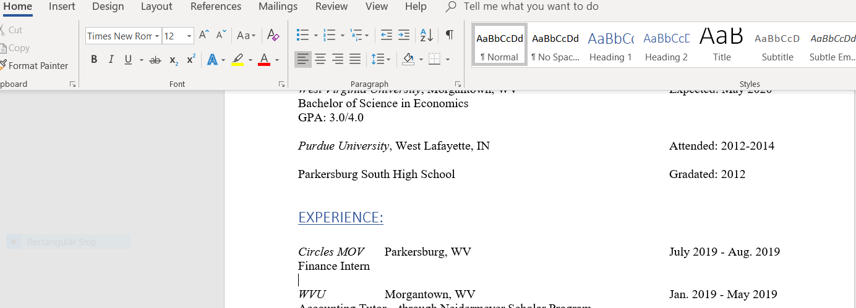
3
2
1
I highlighted “Circles MOV” and then clicked “Italics” (#1). Next, I typed in “Parkersburg, WV”. Finally, I used “Tab” to line up the date with all the other dates. When I typed in “July 2019 – Aug. 2019”, the computer automatically gave me the long version of – instead of the short -. Go back and backspace the “–” and type in a new “-” or your date might move down to the next line (#2). After that, you can press enter, type “Finance Intern”, and press enter again. The “Bullets” for the list can be found at #3.
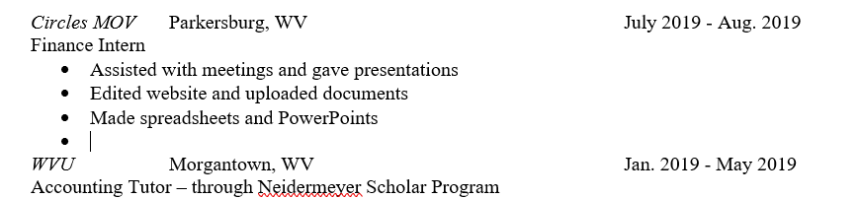
1
Next, I just used bullet points to type the list. After the first bullet point, just press enter to get another bullet point right below the first. When you are done with the bullet points, you will get an extra point if you press enter again (#1). You can press “Backspace” on the keyboard to get rid of the extra bullet.
- Fix any issues you see with the document – we want our resumes to look professional!
Here’s what I did. You can modify the document however you want for this step, but try to match my “Experience” section. I pushed my “Accomplishment” section to the next page. Then I took away the extra spaces before the “Skills” section. My finished product is below, although it doesn’t show the top picture. Nothing above “Experience” was modified since step 3, so you can just look at that picture if you want to look at the completed top of the resume.
