3
2
1
#1: This is the “Home” tab on Microsoft word. You will do most of your work under the home tab, and whenever you open a new document, you should see this screen above. When I say tab, I mean “one of several small, labeled, clickable areas at the top of a window or program” instead of the Tab button on the keyboard. You can use the “File” tab to save and print your documents, but we will explain that later.
#2: This red circle in the bottom right corner shows you where you can change the “Zoom” or size of your document. If you have trouble seeing the document, try changing the settings in this circle.
#3: The top 3 circles are places you click to open up the “Font”, “Paragraph”, and “Styles” menus. They already have the most commonly used items on the screen, so you might not click these very often. I’ll give a brief demonstration of these things on the next page.
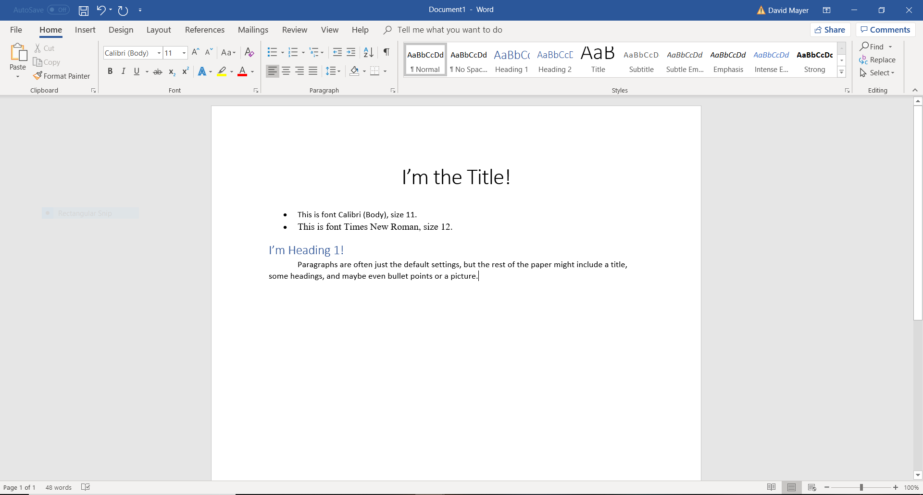
3
2
1
#1: You can click the “Title” style and then start typing, or you can highlight previous text and then select “Title” to change your text. In the picture, I selected Title. Then I typed “I’m the Title!” and used the “Center” button under “Paragraph”. Finally, I pressed “Enter” on my keyboard to go to the next line and clicked the bullets to start a new list (#3). It automatically took me out of the “Title” style and into “Normal” style.
#2: This is the default Font and Size for text. I like Times New Roman, size 12 (another common font and size), so I click the box in circle 2 to see a list of all the fonts. The size of the text can be changed by clicking the box to the right of the “Font” box.
#3: The red circle shows the “Center” button that I used to set the title in the middle of the paper. The bulleted list is indicated by the other arrow.
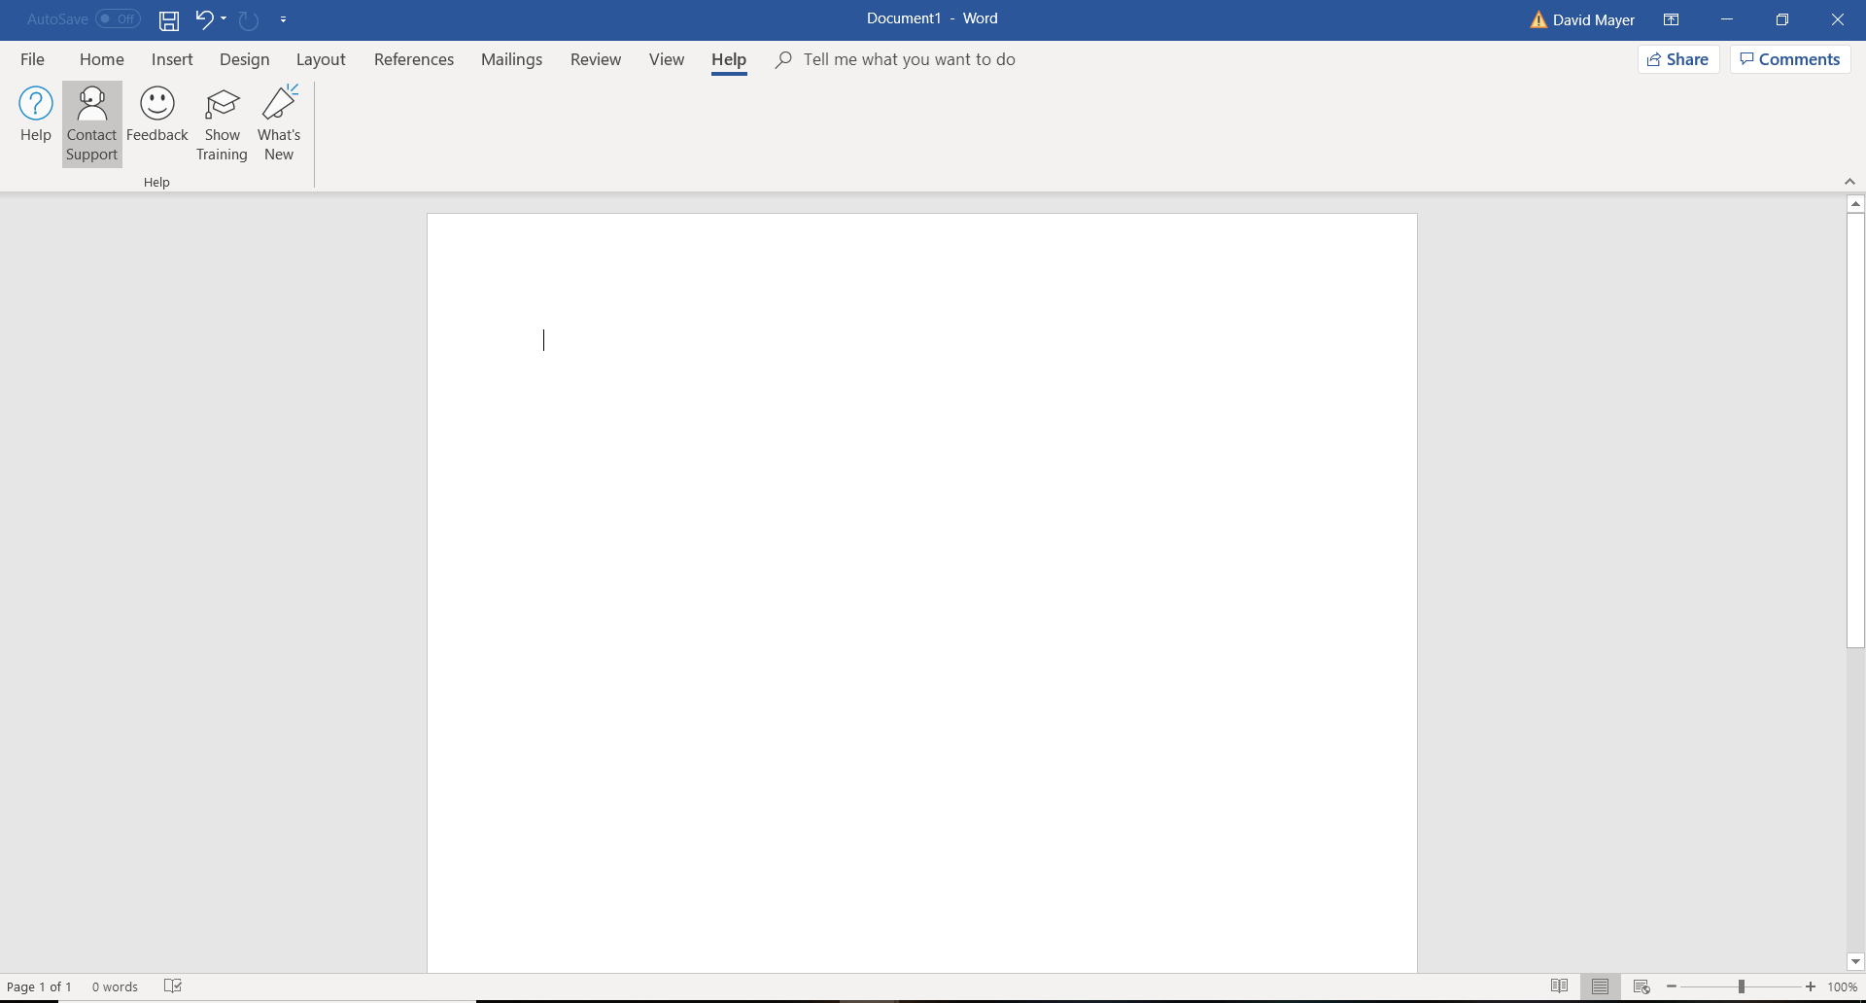
2
1
You may use the “Layout” tab some for formatting, and you might use the “Insert” tab to add pictures. I’m not going over those tabs in this tutorial, but I will tell you about the “Help” tab. If you run into trouble, try clicking the “Help” tab (#1) and then “Contact Support” (#2).
There are also some guides available online. If you have access to YouTube, you can try to find help online. I thought this guide - https://www.youtube.com/watch?v=S-nHYzK-BVg by Technology for Teachers and Students – was quite helpful. Let’s practice modifying a document, and then I will explain how to save documents and find old documents.

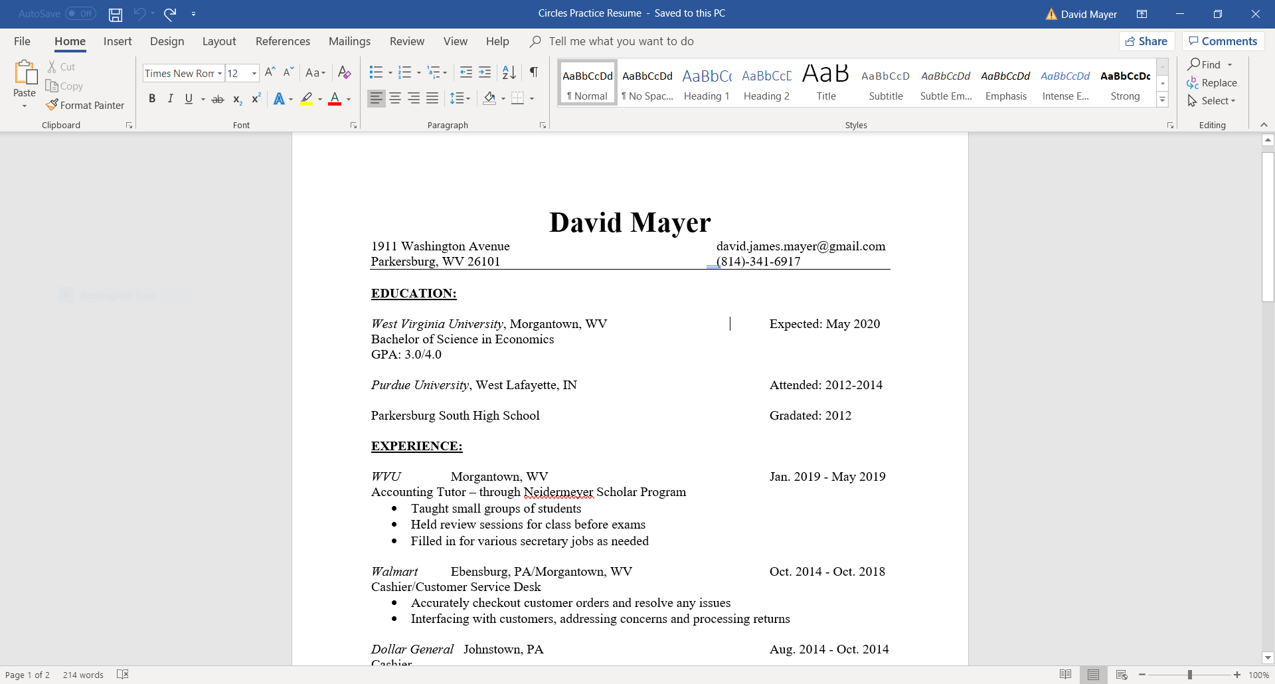
1
Try to open up the document (practice resume document) from the Circles website (https://www.circlescampaignmov.org). You can find it under the “Helpful Tools” tab on the “Microsoft Word – Practice Resume” page. You should see a document on the page that looks like this document above. After you click and download the documents, the first thing I want you to do is to go up to #1 and open the “File” tab. It will start as “Info”, but we want to click on “Save As”.

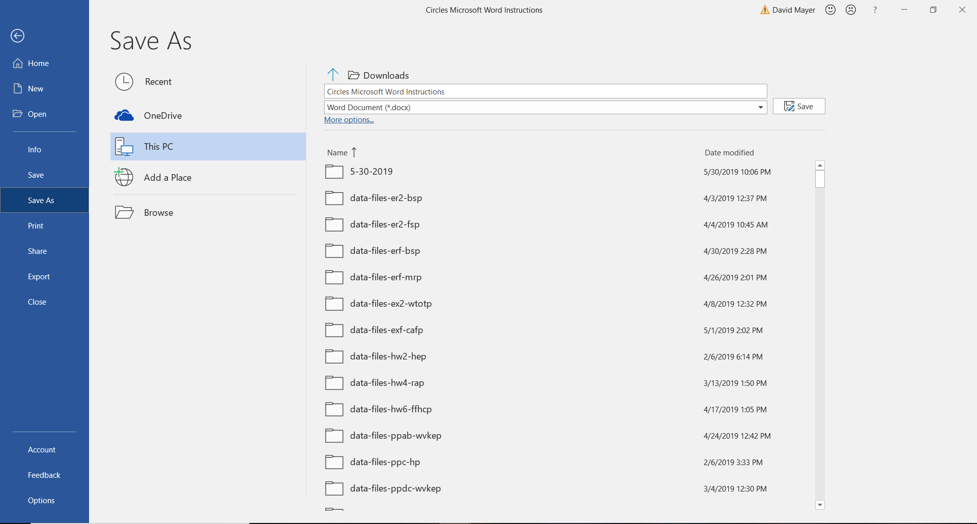
4
3
2
1
#1: This is the “Info” tab that you start at. You need to click #2: “Save As” to get the screen with #3 to appear. My folder says “Downloads”. The folder doesn’t always say Downloads; sometimes it says other things like “Documents”. You can click the blue arrow next to Downloads to change your folder. Right under that is the name of the document. The name of my document, “Circles Microsoft Word Instructions”, will be different than the name of your document. Let’s erase that name and replace it with “Practice Resume Start”.
#4: Click “Save” after you have changed the name of the document. Saving the document will take you right back to the “Home” tab so you can start changing the document. We want to change some things on this resume, so let’s get started. I’ll give you the instructions now – try to complete them on your own. The step-by-step solution is on another document.

Instructions

- Highlight the name, David Mayer, and change it to the “Title” style. Then make sure the name is centered in the same place it was before.
- Change the address from “1911 Washington Avenue to “117 Top of the Rock Drive
Parkersburg, WV 26101” Morgantown, WV 26508”
Note: you should keep the email address and the phone number in about the same place they were before.
- Change all the headings (Education, Experience, Accomplishments, Skills, and Hobbies and Interests) to “Heading 1” style. You may need to underline the headings again.
- Add new work experience right under the Experience heading. The information is:
Circles MOV, Parkersburg, WV, July 2019 – August 2019
Finance Intern
Assisted with meetings and gave presentations
Edited website and updated documents
Made spreadsheets and PowerPoints

Note: Use “Italics” under “Font” for Circles MOV. Make bullet points for the list under Finance Intern. Try to keep the format the same as the rest of the work experience.

- Fix any issues you see with the document – we want our resumes to look professional!
*You can find the solution on the Circles website below the practice resume on the “Microsoft Word – Practice Resume” page.

Saving and Finding Files
- Instruction #6: Save the finished resume as “Practice Resume Finish”.
Now that you have learned how to modify your resume, you will need to know how to look up old documents. If you “Save” a file (not “Save As”), you will automatically update the file with the same name. For example, you can open up your resume and make a few changes. When you save, your computer will forget the old version and show you the new version the next time you open your resume.
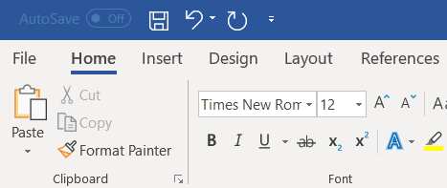
Click here to Save your current document.
You can always use “Save As” under the File tab when you want to save your document to a new spot. If the document was saved under another name, this will make a copy of that document – you can use this to keep an old version of a document and a new version. If you try to save a document with “Save As” and you pick a name that has already been used, the computer will ask you if you want your current document to replace the old document. Be careful not to delete anything that you will need later!
To open an old document, go to the “File” tab and look for “Open”.
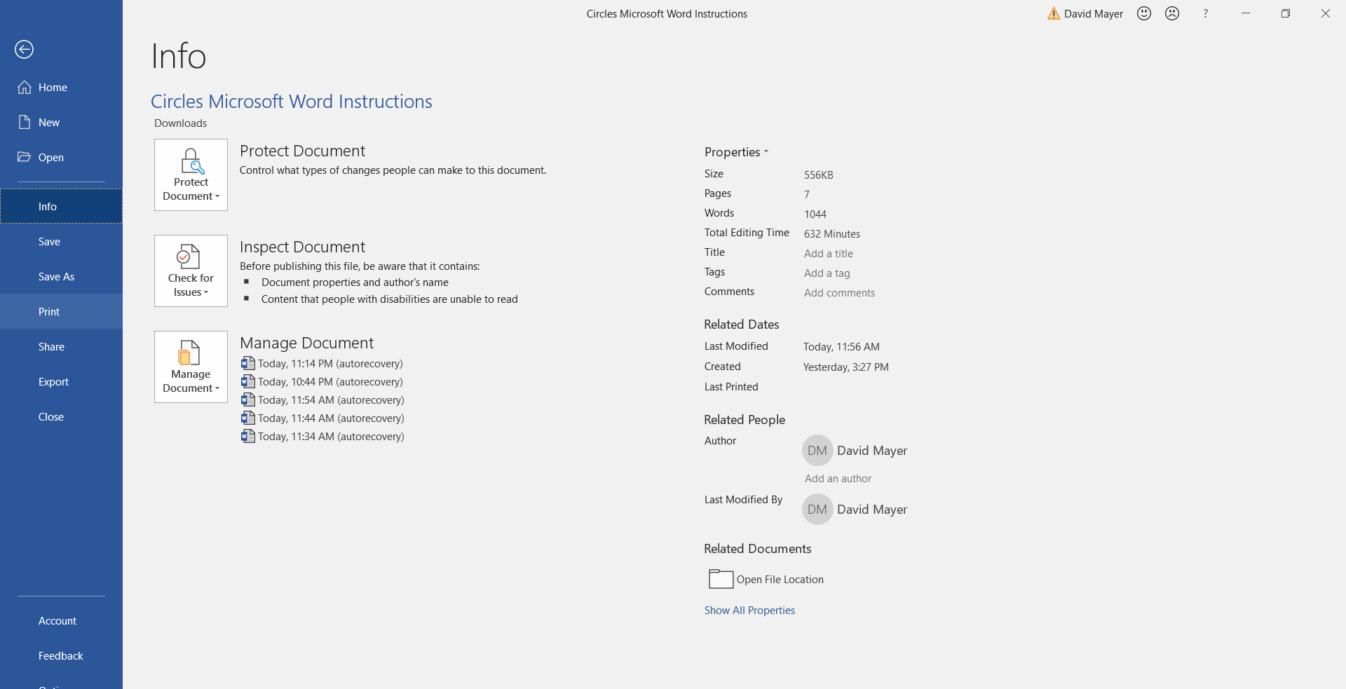
You can usually find what you are looking for just by looking at documents because the default is “Recent”. If I just wanted to find the most recent document, I would just press “Open” and the “Circles Practice Resume Finish” would be the top result (#1). If I don’t find what I’m looking for, I click “Browse” (#2).
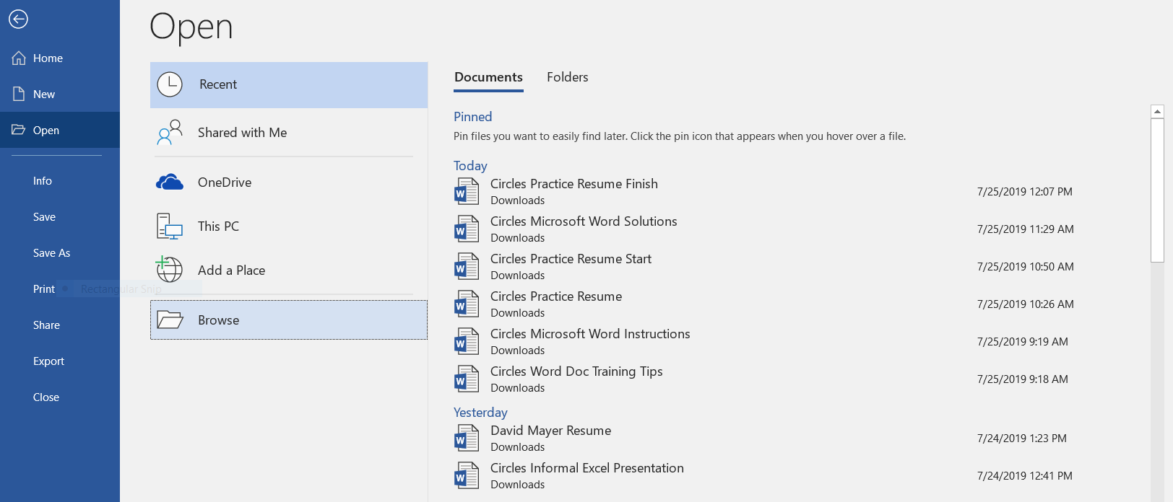
2
1
“Browse” opens a menu that has access to all your files, but the files can be hard to find. It is easiest if you know exactly what you named the file, so you can just type that name into the search bar (#1). If the search function doesn’t work, try scrolling through the list. The list will only cover one “Folder”, so you need to know which folder you should look in. Remember that I said my folder was “Downloads” when I first saved my document?
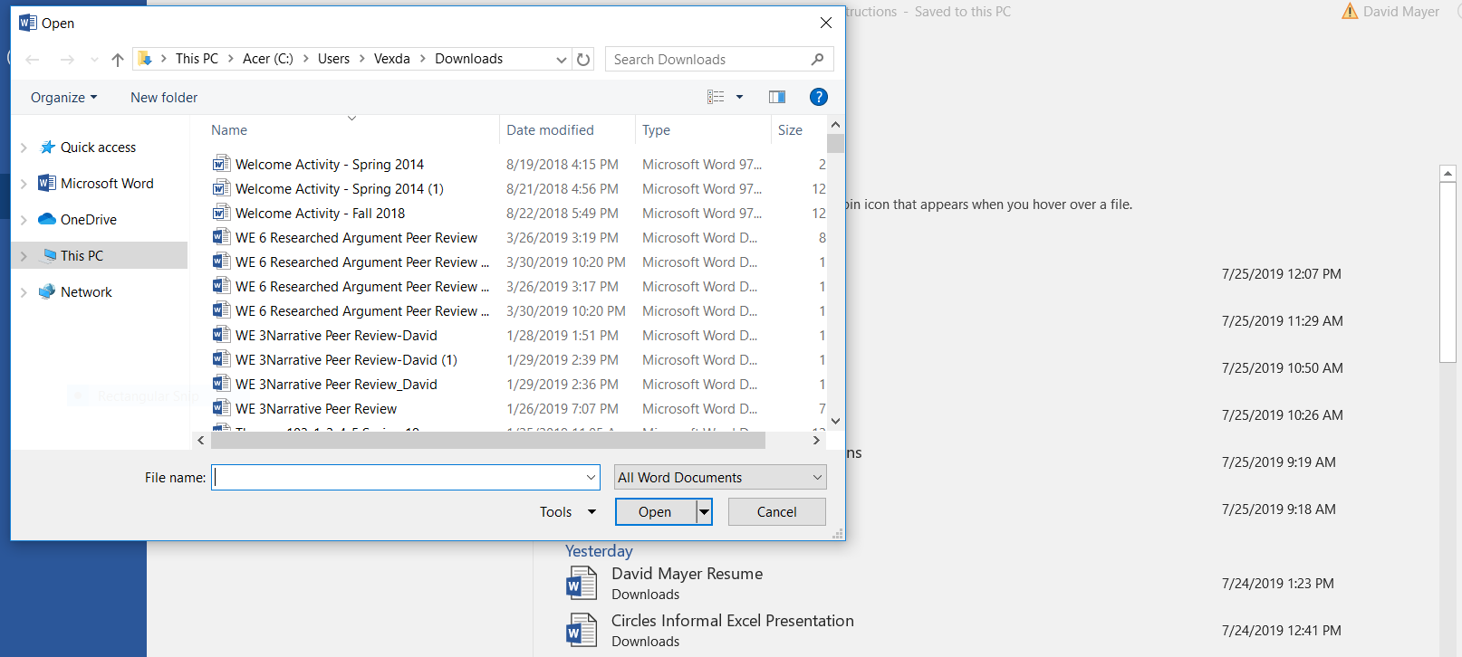
1

If you still can’t find your document, I suggest asking someone else for help or watching a guide on YouTube. If you have technological issues, feel free to contact us at Circles! We’re happy to help, and we want your feedback!

